Infosys Springboard Virtual Internship 6.0 Completion Report

Team Details

Batch Number : 13 Start date : 2 Feb 2026
Name : Daksh Jain
Internship Duration: 8 Weeks

Project Title
Web Application for Product Price Comparison Across E-Commerce Sites.

Project Objective
This project presents an AI-powered web application that recognizes products from uploaded images, Links and compares their prices across platforms like Amazon and eBay,Flipkart,etc. It enables users to instantly find the best deals, making online shopping faster, smarter, and more cost-effective.

Project description in detail
Approach : The system uses AI to identify products from images or links and compares prices across platforms like Amazon and Flipkart using APIs and web scraping.
Technologies Used :
Frontend: React.js, Bootstrap
Backend: Python, Django
AI/Image Recognition: Qwen3.5 vision model
Database: MySQL
Other: Price Alert Service, Email Notifications, Django Scheduler
Real-World Impact : Saves users time and effort by finding the best deals quickly, making online shopping faster, smarter, and more cost-effective.

- Timeline Overview
Week | Activities Planned | Activities Completed
Week 1 | Home Page & Authentication | Built home page UI, Implemented login & signup, Integrated authentication APIs.
Week 2 | Image & Link Upload, Image & Text Processing. | Developed the functionality to allow users to upload product images.

Week 3 | Price Comparison | Set up web scraping techniques from e-commerce platforms
Week 4 | Search Integration | Integrate APIs from e- commerce platforms to gather  pricing data
Week 5 | User Interface (UI) | Built an responsive UI for users to upload images and view results.
Week 6 | Product Information Display | Implemented display of detailed product information.
Week 7 | Testing, Review | Review of all implemented  features,functionality,user interface consistency.
Week 8 | Documentation | Preparing the final documentation, including an  overview and technical specifications of Project.

5a. Key Milestones
Milestone | Description | Date Achieved
Project Kickoff | Introduction of Project | 2 Feb 2026
Prototype/First Draft | Home Page & Authentication | 15 Feb 2026
Mid-Term Review | Image & Link Upload, Image & Text Processing. | 1 Mar 2026
Final Submission | Working Project Submission | 15 Mar 2026
Presentation |  | Not Yet Done

5b. Project execution details
  - The frontend was built using React.js and Bootstrap to allow users to search products via images or links.
  - The Django backend received requests, fetched product data from platforms like Amazon and Flipkart using SERP API, and compared prices.
  - Users could set price alerts, which were stored in the database and checked daily using Django schedulers. If prices dropped, email notifications were sent. The system was tested for functionality, reliability, and integrated for smooth end-to-end operation.

Snapshots / Screenshots

- Home page
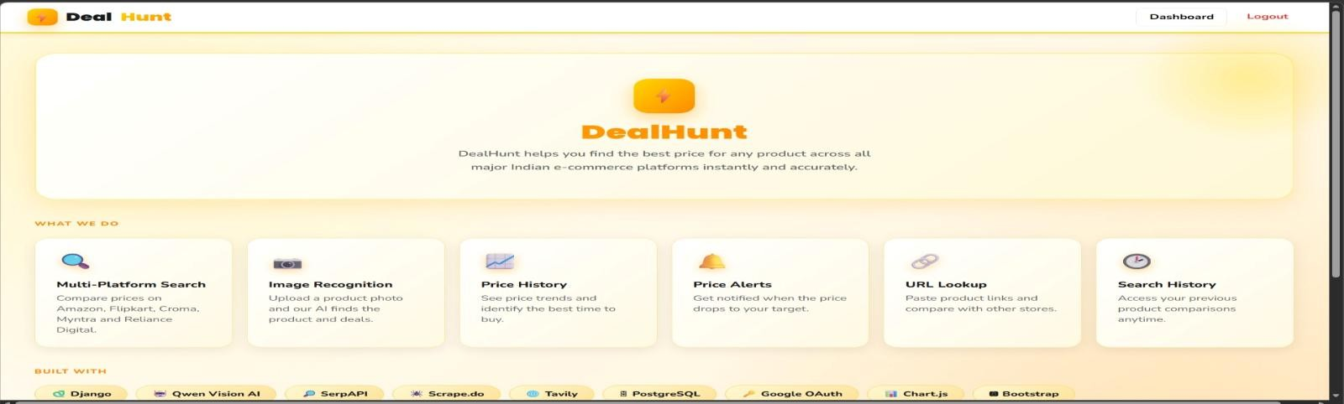
- Login Page
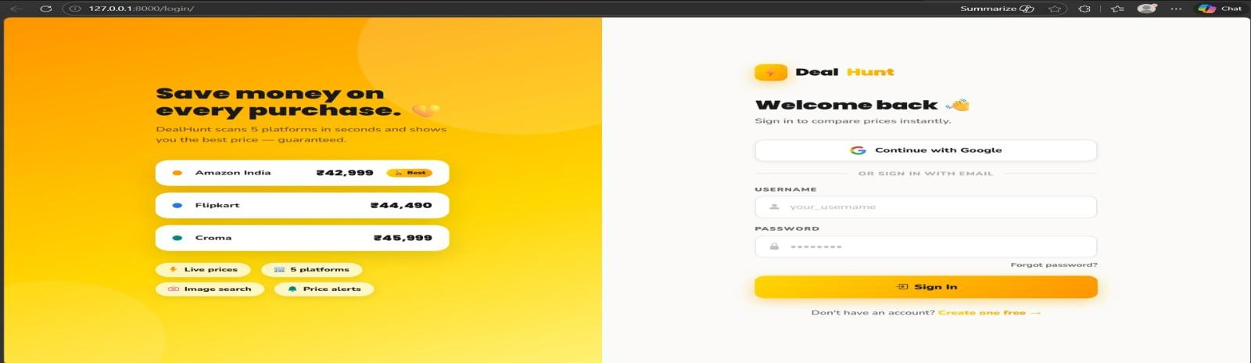

- Dashboard
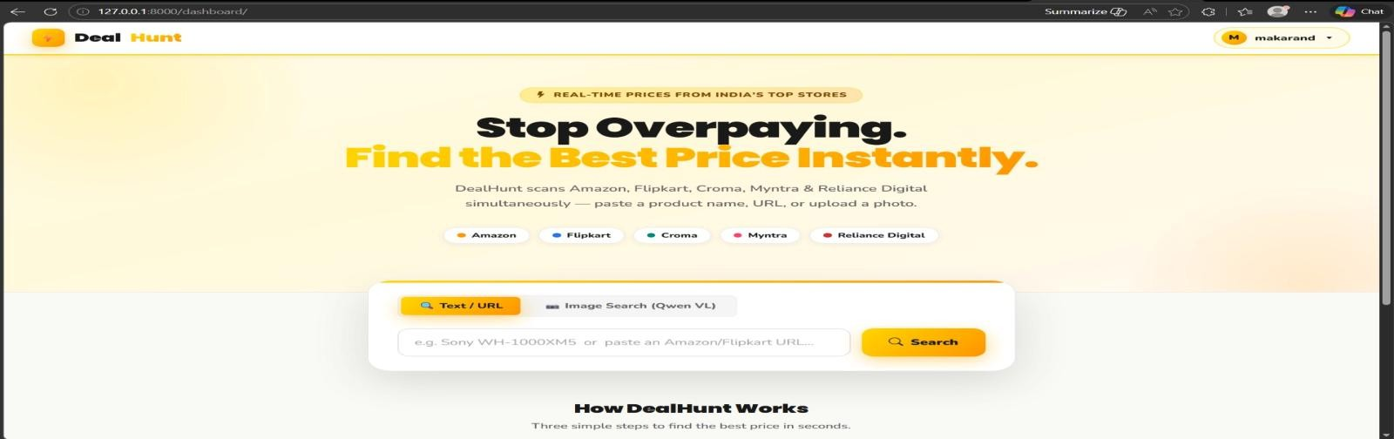

- Price Comparision
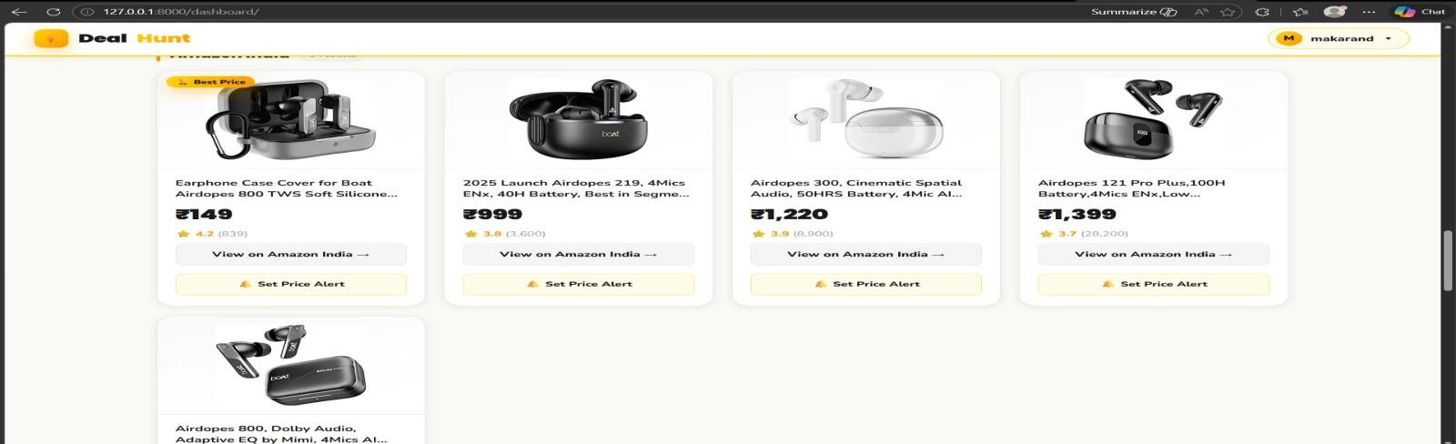

- Set Price Alert
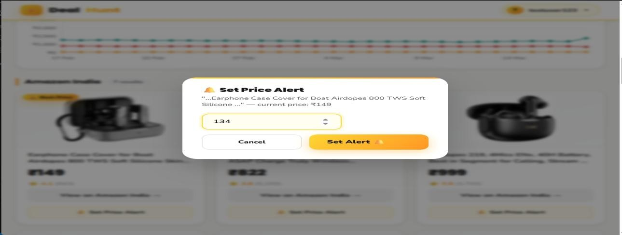

- Price Drop Message
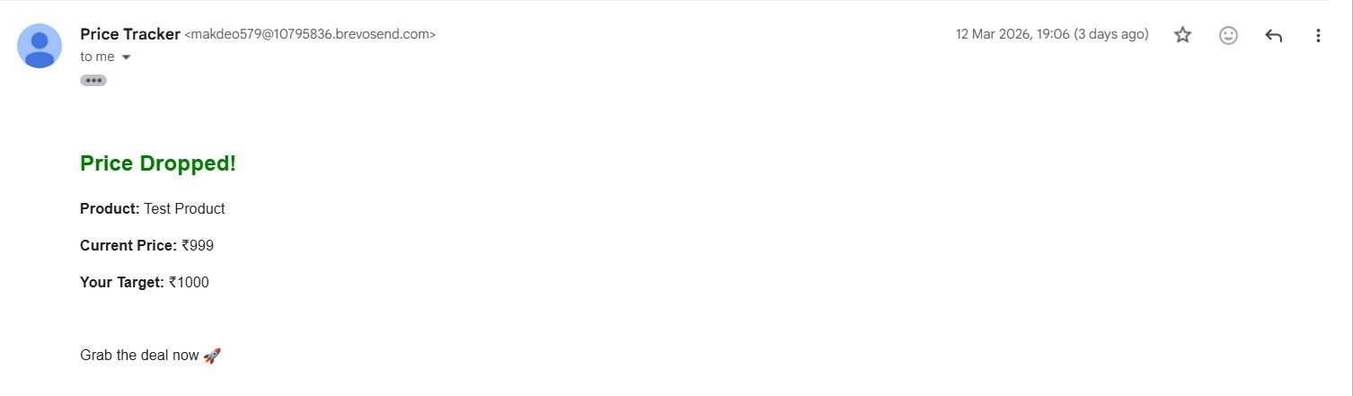

- Search History
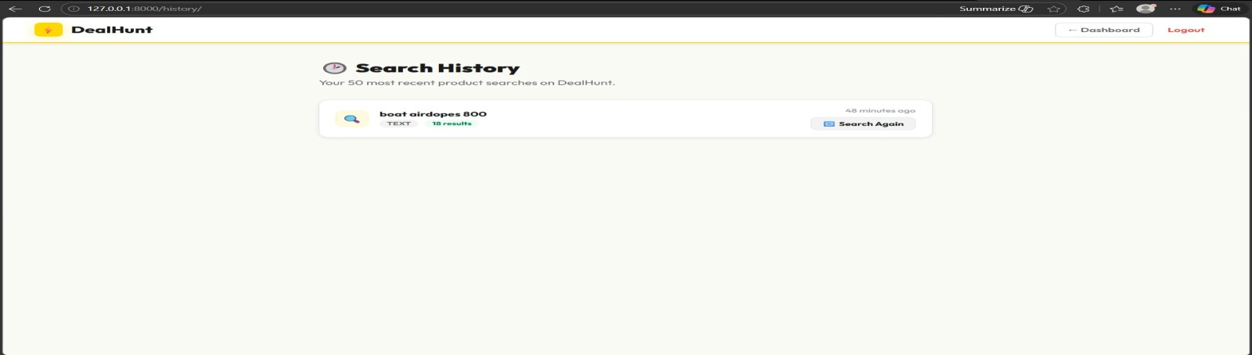

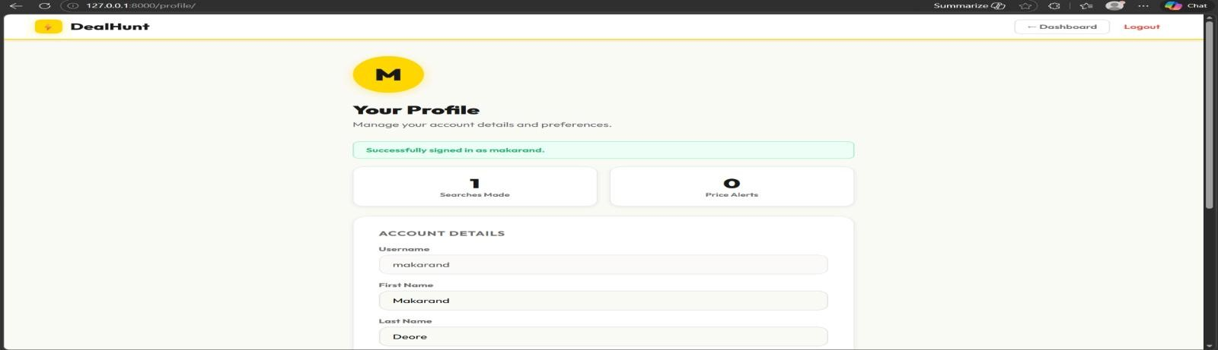
- User Profile

Challenges Faced
  - Managing time and balancing my workload was often challenging, especially when deadlines were tight and some tasks were more complex than expected.
  - I also faced delays in backend integration, which made it difficult for me to test UI features on time and slowed my progress.
  - Additionally, when requirements changed, I experienced miscommunication at times, which led to rework on the frontend side.

Learnings & Skills Acquired
  - Gained practical experience in React.js, Bootstrap, and building responsive, user-friendly interfaces.
  - Learned to integrate frontend with backend APIs and handle dynamic product data.
  - Improved UI/UX design, problem-solving, and team collaboration skills.
  - Developed an understanding of e-commerce workflows and real-world web application development.

Testimonials from team
  - During the internship, I worked collaboratively with my team and contributed to developing the frontend of the application. I coordinated with the backend team for integrating APIs and ensured smooth UI functionality.
  - This experience helped me improve my practical development skills, teamwork, and confidence in working on real-world projects.

Conclusion
This internship gave me practical experience in frontend development and AI-based web applications. I learned to build responsive interfaces, integrate APIs, and work effectively in a team. The project showed how technology can simplify online shopping and improve user experience. Overall, it strengthened my technical skills and aligned well with my career goals in web development.

Acknowledgements
I would like to express my sincere gratitude to the organization for providing me with the opportunity to work on this project and gain practical experience in web development. I am especially thankful to my mentor for their continuous guidance, valuable feedback, and support throughout the internship.
I would also like to thank my team members for their cooperation, collaboration, and encouragement, which helped in successfully completing the project. Their support made this learning experience both productive and enjoyable.

